FANUC X4.7 Installation

1、Output wiring configuration:
Red Wiring：+24VDC Black Wiring：0VDC
Green Wiring： X4.7 skip Yellow：Low Battery Signal

2、Signal Test：
System –PMC -Check the state of X4.7 could be changed to 1 from 0.

3、Test the Skip function:
Turn to the MDI mode and input below words:
G91 G31 X100. F100.;
G91 G01 Y100.F100.;
Press the Cycle Begin button, and watch the when the change of X position number, The G31 movement could be skip when touch the stylus！

4、Install the probe into the CNC axis, and adjust the swing of stylus to less than 0.01MM。
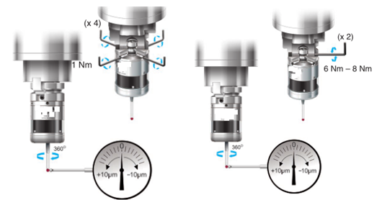

5、Change the parameter：
6200 | SKF | SRE |  | HSS |  |  | SK0
Value | 1 | 0 |  | 1 |  |  | 0
6201 |  |  |  |  |  |  | SEB | SEA
Value |  |  |  |  |  |  | 1 | 0
3708 |  |  |  |  |  |  |  | SAR
Value |  |  |  |  |  |  |  | 0

